**Business Intelligence Assignment:**

**1) With Jio coming in, we have seen an influx of internet users from Tier 2 and Tier 3.**

**Video/Content apps like YouTube and Tik-Tok have seen a huge growth while**

**Amazon/Flipkart haven’t seen similar.**

**What could be the reason for it? Feel free to use any publicly available data to support**

**your hypotheses.**

**Ans**: Since when Jio came into the market It provide lot of data in less amount, people is spending lot of time on the YouTube and tik-Tok and doing other social media activity.

Let’s assume you want to buy something online you will spend 1 and 2 hours only on Amazon Myntra or Flipkart. People always search for the entertainment so they always want a platform where they can find the videos, movies and song that’s why they spend lots of time on YouTube and Tik-Tok. Since when the govt. banned the Tik-Tok there is one app developed by Indian is “Snack”. So, we need to develop an app where people can find everything on the same application.

**2) New Onboarding Design at Nymtra**

Nymtra is India’s leading fashion app. The Product team revamped the app’s Onboarding

Flow on 31st July that introduced the following features:

● New walkthrough with 3 screens highlighting - extensive catalogue, free

shipping for the first-order, and easy returns

● Added a ‘Skip Login’ option to the login screen at the end of the walkthrough

● Added a new “10,000+ items under ₹999” banner on the home screen.

You are attending the product review meeting on 5th November where the team looks at

the following data:

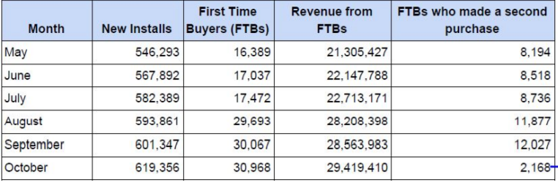

Question: Is the onboarding flow revamp a success? Justify

**Ans:** No, we can clearly see into the data provided by you. There is lot’s of FTBs in the starting but the second time it is decreasing by Half in very months. We should give some offer to those costumers coming for twice on Nymtra for Increasing the profit. I can give you one Real-world example. As we know when Jio sim is introduced initially it was free sometime when they eliminate all the service provider and make the customer all over the India then they required for the recharges.

So just like Jio 1st we should make the customer.

**3) Personalised Recommendations at FilmiStar.**

Part A:

FilmiStar is India’s #1 app for watching movies. The Product team was tasked with designing a new carousel on the home screen that will show personalised movie recommendations based on the user’s taste. Currently, the home screen shows trending and new movies only.

Questions:

**1) What will be the change in user behaviour once this feature is introduced?**

**Ans:** If this feature introduced in the FILMISTAR, it will be the easy for the user to find out list of the movies and song which will be liked by the User. Because Whenever the user open the Filmistar he/she will get the recommended movies list according to there watch history Like a person how does not like love story or romantic movies he /she always watch the action movies so they will get action movies as per there watch History. It will save the time of the user.

**2) What should be the goals and metrics for this feature?**

**Ans:** Monitor the watch History of the user or ask the user in which type of movies are you interested, as per there choice maximum number of movies show in the Home Screen. That should be our goal.

**3) How should this feature be launched and evaluated?**

**Ans:**  A features launch requires a lot of market research, advertise about the feature on different social media platform, Increase the customer loyalty, internal coordination across the organization, and communication with the public before the new feature generally becomes available in the product. Before launching the features publicly, we should apply this on some of the user and notice the responds and according to the responds then launch publicly.